CPE301 – SPRING 2019

Design Assignment 1B

Student Name: Clayton Higbee

Student #: 5001189864

Student Email: higbee@unlv.nevada.edu

Primary Github address:

Directory:

Submit the following for all Labs:

1. In the document, for each task submit the modified or included code (only) with highlights and justifications of the modifications. Also, include the comments.
2. Use the previously create a Github repository with a random name (no CPE/301, Lastname, Firstname). Place all labs under the root folder ESD301/DA, sub-folder named LABXX, with one document and one video link file for each lab, place modified asm/c files named as LabXX-TYY.asm/c.
3. If multiple asm/c files or other libraries are used, create a folder LabXX-TYY and place these files inside the folder.
4. The folder should have a) Word document (see template), b) source code file(s) and other include files, c) text file with youtube video links (see template).

1. **COMPONENTS LIST AND CONNECTION BLOCK DIAGRAM w/ PINS**

Atmega328PB

10k Potentiometer

On/Off Switch

MD08A/TB6612FNG – Motor Driver/H Bridge

5V DC motor

Atmega328P to Motor Driver

PD5 to PWMA

Motor Driver Internals

STBY to VCC

VMOT to VCC

AIN1 to VCC

Motor Driver to DC Motor

AO1 to + Terminal

AO2 to – Terminal

Atmega328P to Potentiometer

PCO to Data out

Atmega328P to Switch

PC2 to Data out

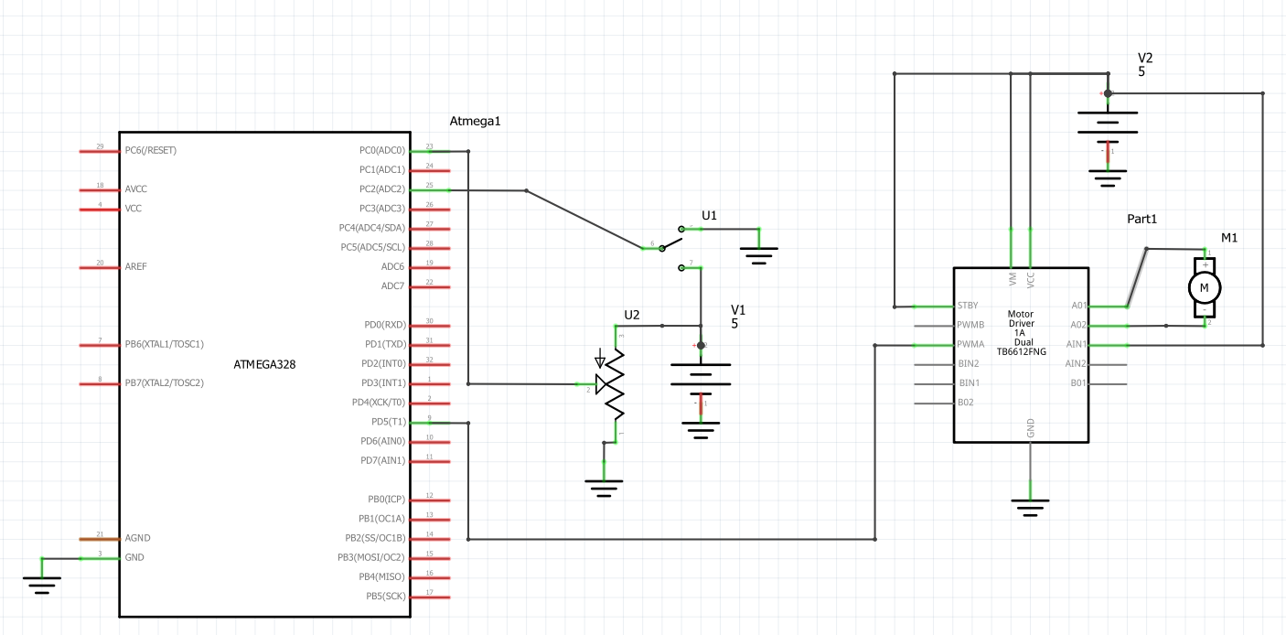

1. **INITIAL/MODIFIED/DEVELOPED CODE OF TASK 1/A**

/*

* DA4A.c

*

* Created: 4/11/2019 11:35:52 AM

* Author : clayt

*/

#define *F_CPU* 16000000UL

#include <avr/io.h>

#include <stdio.h>

#include <util/delay.h>

#include <avr/interrupt.h>

// Define Baudrate for UART

#define BAUDRATE 9600

#define BAUD_PRESCALLER (((*F_CPU* / (BAUDRATE * 16UL))) - 1)

// Function Declarations

void read_adc(void);

void adc_init(void);

void USART_init( unsigned int ubrr );

void USART_tx_string( char *data );

volatile unsigned int adc_value;

char outs[20];

int main(void)

{

adc_init(); // Initialize the ADC

USART_init(BAUD_PRESCALLER); // Initialize the USART

USART_tx_string("Connected!\r\n"); // we're alive!

*_delay_ms*(125); // wait a bit

/* PWM Initializer */

DDRD = 0xFF; //DDRD = (1<<3); // Set Port D as an output direction THIS IS REQUIRED TO OUTPUT THE PWM

// In the next line of code, we:

// 1. Set the compare output mode to clear OC2A and OC2B on compare match.

// To achieve this, we set bits COM2A1 and COM2B1 to high.

// 2. Set the waveform generation mode to fast PWM (mode 3 in datasheet).

// To achieve this, we set bits WGM21 and WGM20 to high.

TCCR2A = _BV(COM2A1) | _BV(COM2B1) | _BV(WGM21) | _BV(WGM20);

// In the next line of code, we:

// 1. Set the waveform generation mode to fast PWM mode 7 —reset counter on

// OCR2A value instead of the default 255. To achieve this, we set bit

// WGM22 to high.

// 2. Set the prescaler divisor to 1, so that our counter will be fed with

// the clock's full frequency (16MHz). To achieve this, we set CS20 to

// high (and keep CS21 and CS22 to low by not setting them).

TCCR2B = _BV(WGM22) | _BV(CS20) | _BV(CS21) | _BV(CS22);

// OCR2A holds the top value of our counter, so it acts as a divisor to the

// clock. When our counter reaches this, it resets.

OCR2A = 255;

// This is the duty cycle. Think of it as the last value of the counter our

// output will remain high for. Can't be greater than OCR2A of course.

OCR2B = 0;

/* Pin Change Interrupt initializer */

PCMSK1 |= (1<<PCINT10); // Enable PCINT10 for pin change interrupt

PCICR |= (1<<PCIE1); // Pin change interrupt control register, set Pin Change interrput Enable Register 1

sei(); // Set Global interrupt

while (1)

{

read_adc();

*_delay_ms*(250);

adc_value = adc_value/4;

*snprintf*(outs,sizeof(outs),"%3d\r\n", adc_value); // print it

USART_tx_string(outs); // Print adc value

OCR2B = adc_value; // Replace with adc value

}

}

/* INIT ADC */

void adc_init(void)

{

/** Setup and enable ADC **/

ADMUX = (0<<REFS1)| // Reference Selection Bits

(1<<REFS0)| // AVcc - external cap at AREF

(0<<ADLAR)| // ADC Left Adjust Result

(0<<MUX2)| // Analog Channel Selection Bits

(0<<MUX1)| // ADC0 (PC0 PIN27)

(0<<MUX0);

ADCSRA = (1<<ADEN)| // ADC ENable

(0<<ADSC)| // ADC Start Conversion

(0<<ADATE)| // ADC Auto Trigger Enable

(0<<ADIF)| // ADC Interrupt Flag

(0<<ADIE)| // ADC Interrupt Enable

(1<<ADPS2)| // ADC Prescaler Select Bits

(0<<ADPS1)|

(1<<ADPS0);

}

/* READ ADC PINS */

void read_adc(void)

{

unsigned char i = 4;

adc_temp = 0;

while (i--)

{

ADCSRA |= (1<<ADSC);

while(ADCSRA & (1<<ADSC));

adc_temp+= ADC;

*_delay_ms*(50);

}

adc_value = adc_value / 4; // Average a few samples

}

/* INIT USART (RS-232) */

void USART_init( unsigned int ubrr )

{

UBRR0H = (unsigned char)(ubrr>>8);

UBRR0L = (unsigned char)ubrr;

UCSR0B = (1 << TXEN0); // Enable RX, TX & RX interrupt

UCSR0C = (3 << UCSZ00); //asynchronous 8 N 1

}

/* SEND A STRING TO THE RS-232 */

void USART_tx_string( char *data )

{

while ((*data != '\0'))

{

while (!(UCSR0A & (1 <<UDRE0)));

UDR0 = *data;

data++;

}

}

ISR(PCINT1_vect){

DDRD ^= 0xFF; // XOR direction register to either turn motor off or on depending on which has occured last

*_delay_ms*(1000); //Ground Bounce

char check = "Pin Change ";

USART_tx_string(check); // Print at the time of pin change occurance

}

1. **DEVELOPED MODIFIED CODE OF TASK 2/A from TASK 1/A**

No modified sections of code needed for this assign

1. **SCHEMATICS**



1. **SCREENSHOTS OF EACH TASK OUTPUT (ATMEL STUDIO OUTPUT)**

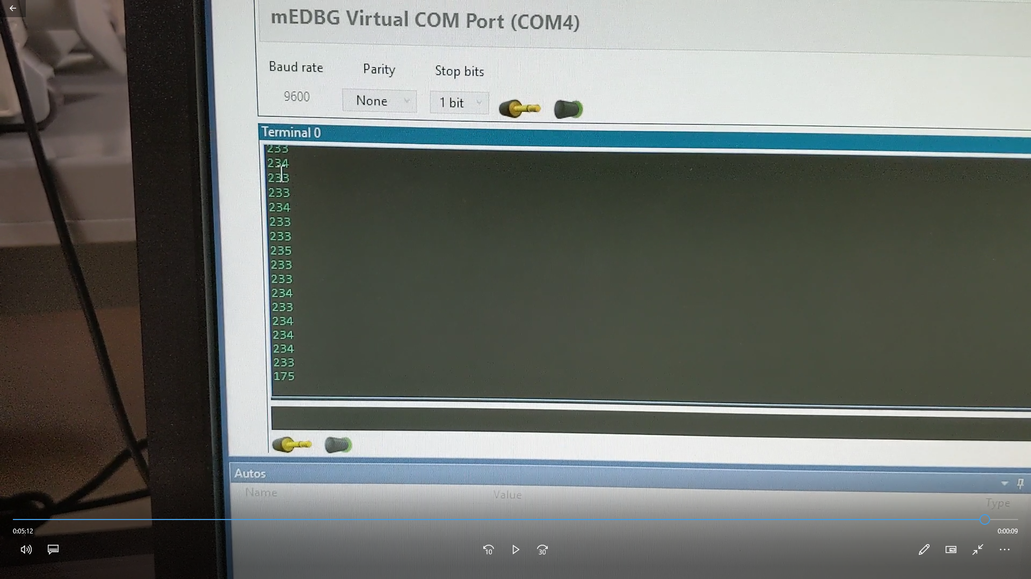

UART Print of ADC value

1. **SCREENSHOT OF EACH DEMO (BOARD SETUP)**

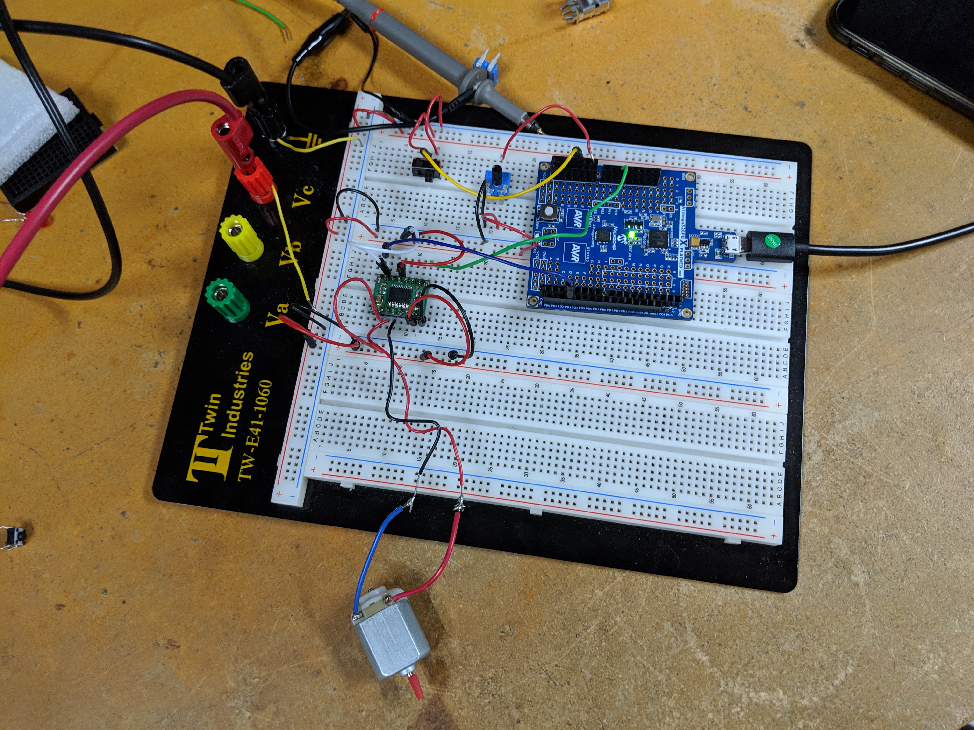

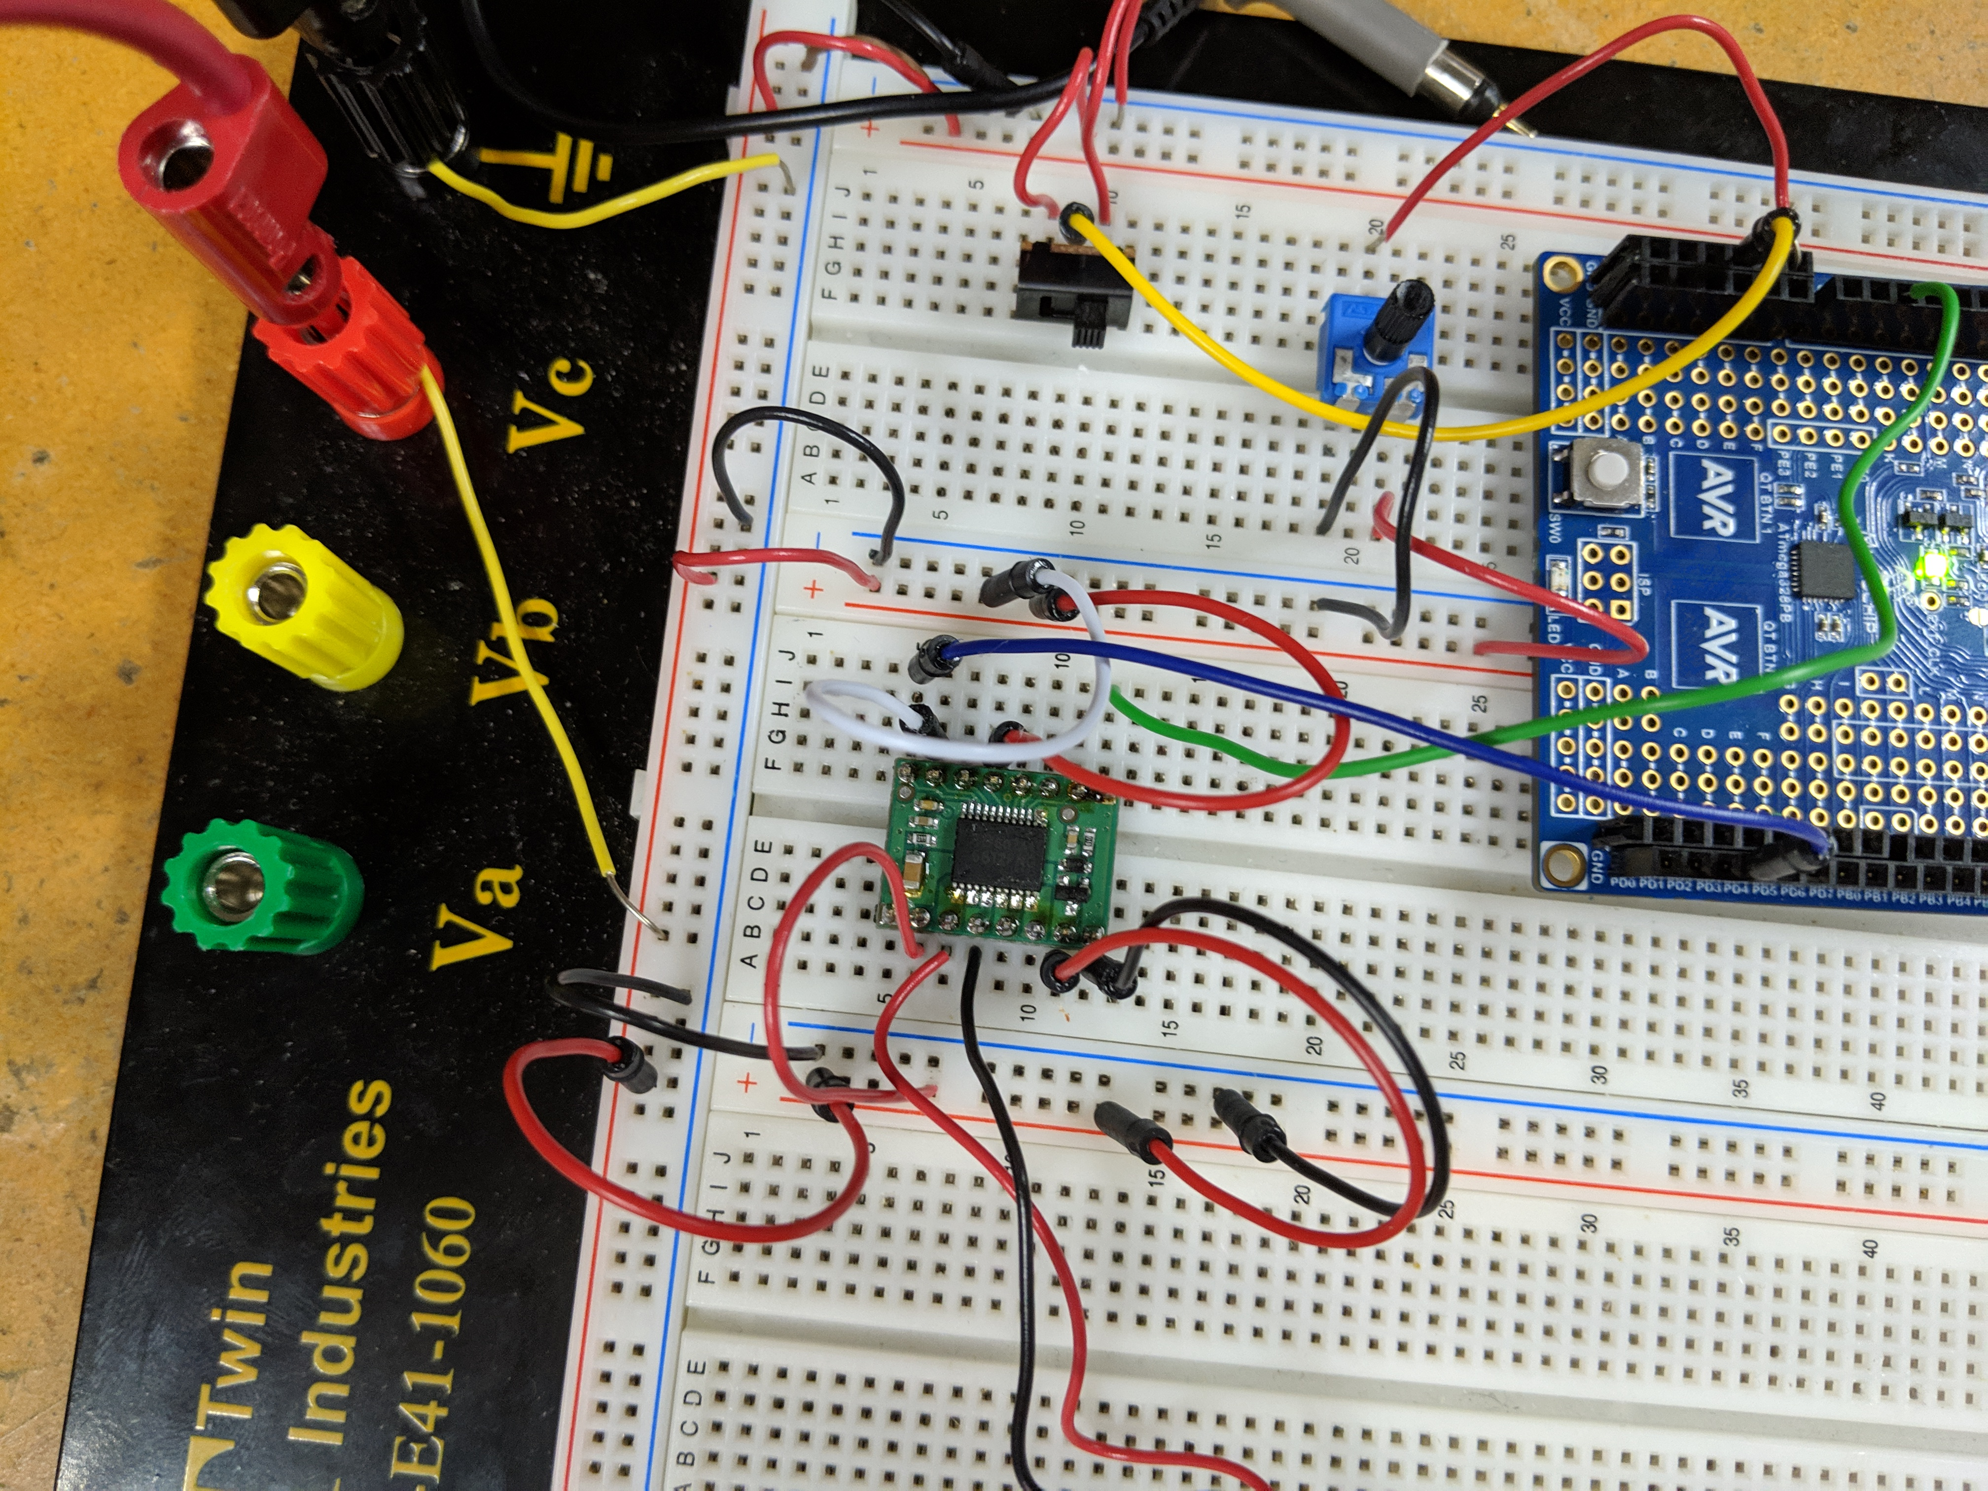

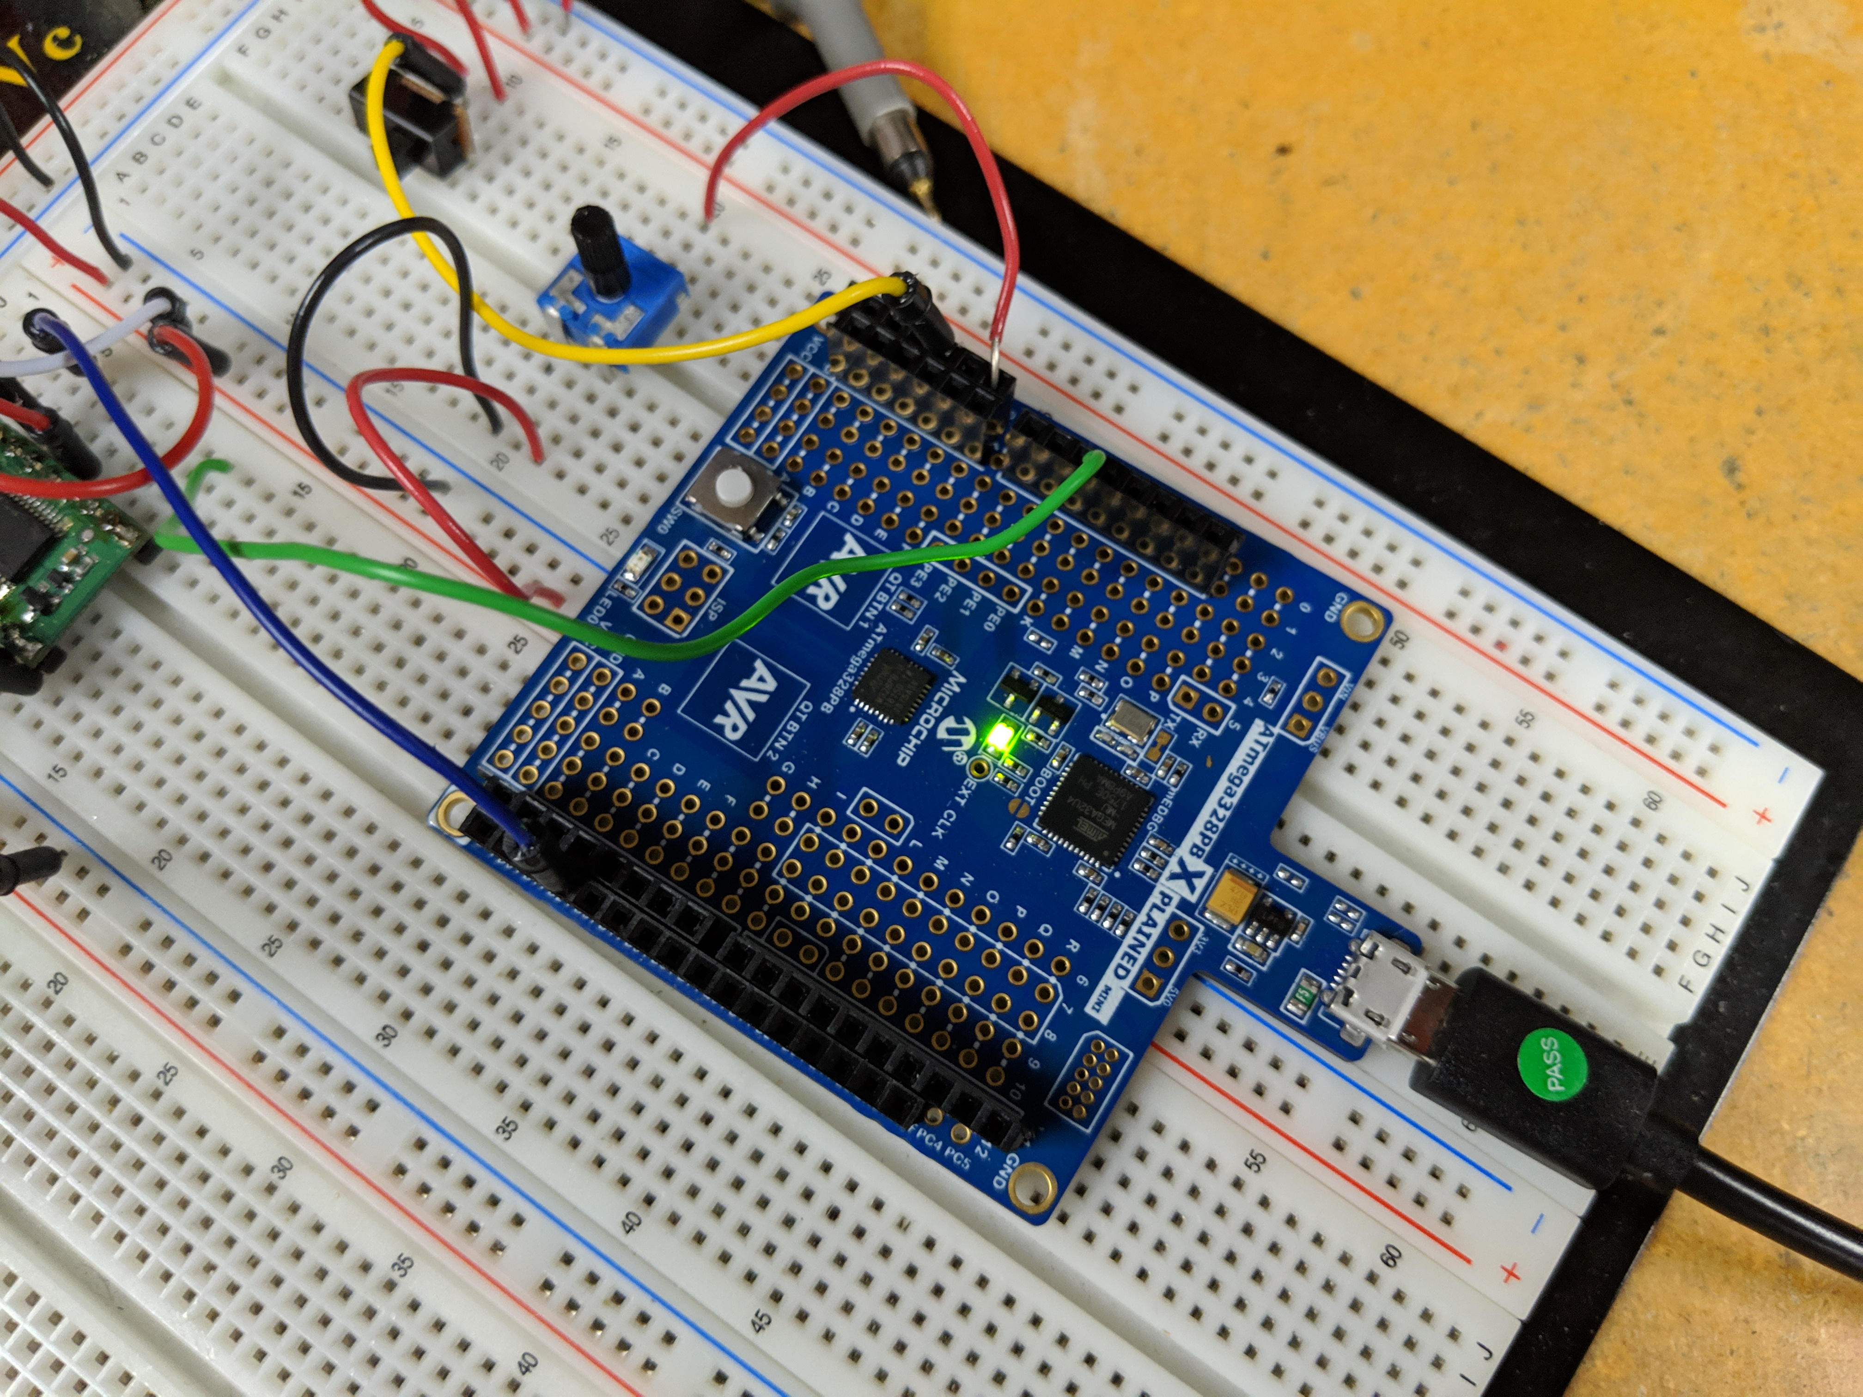

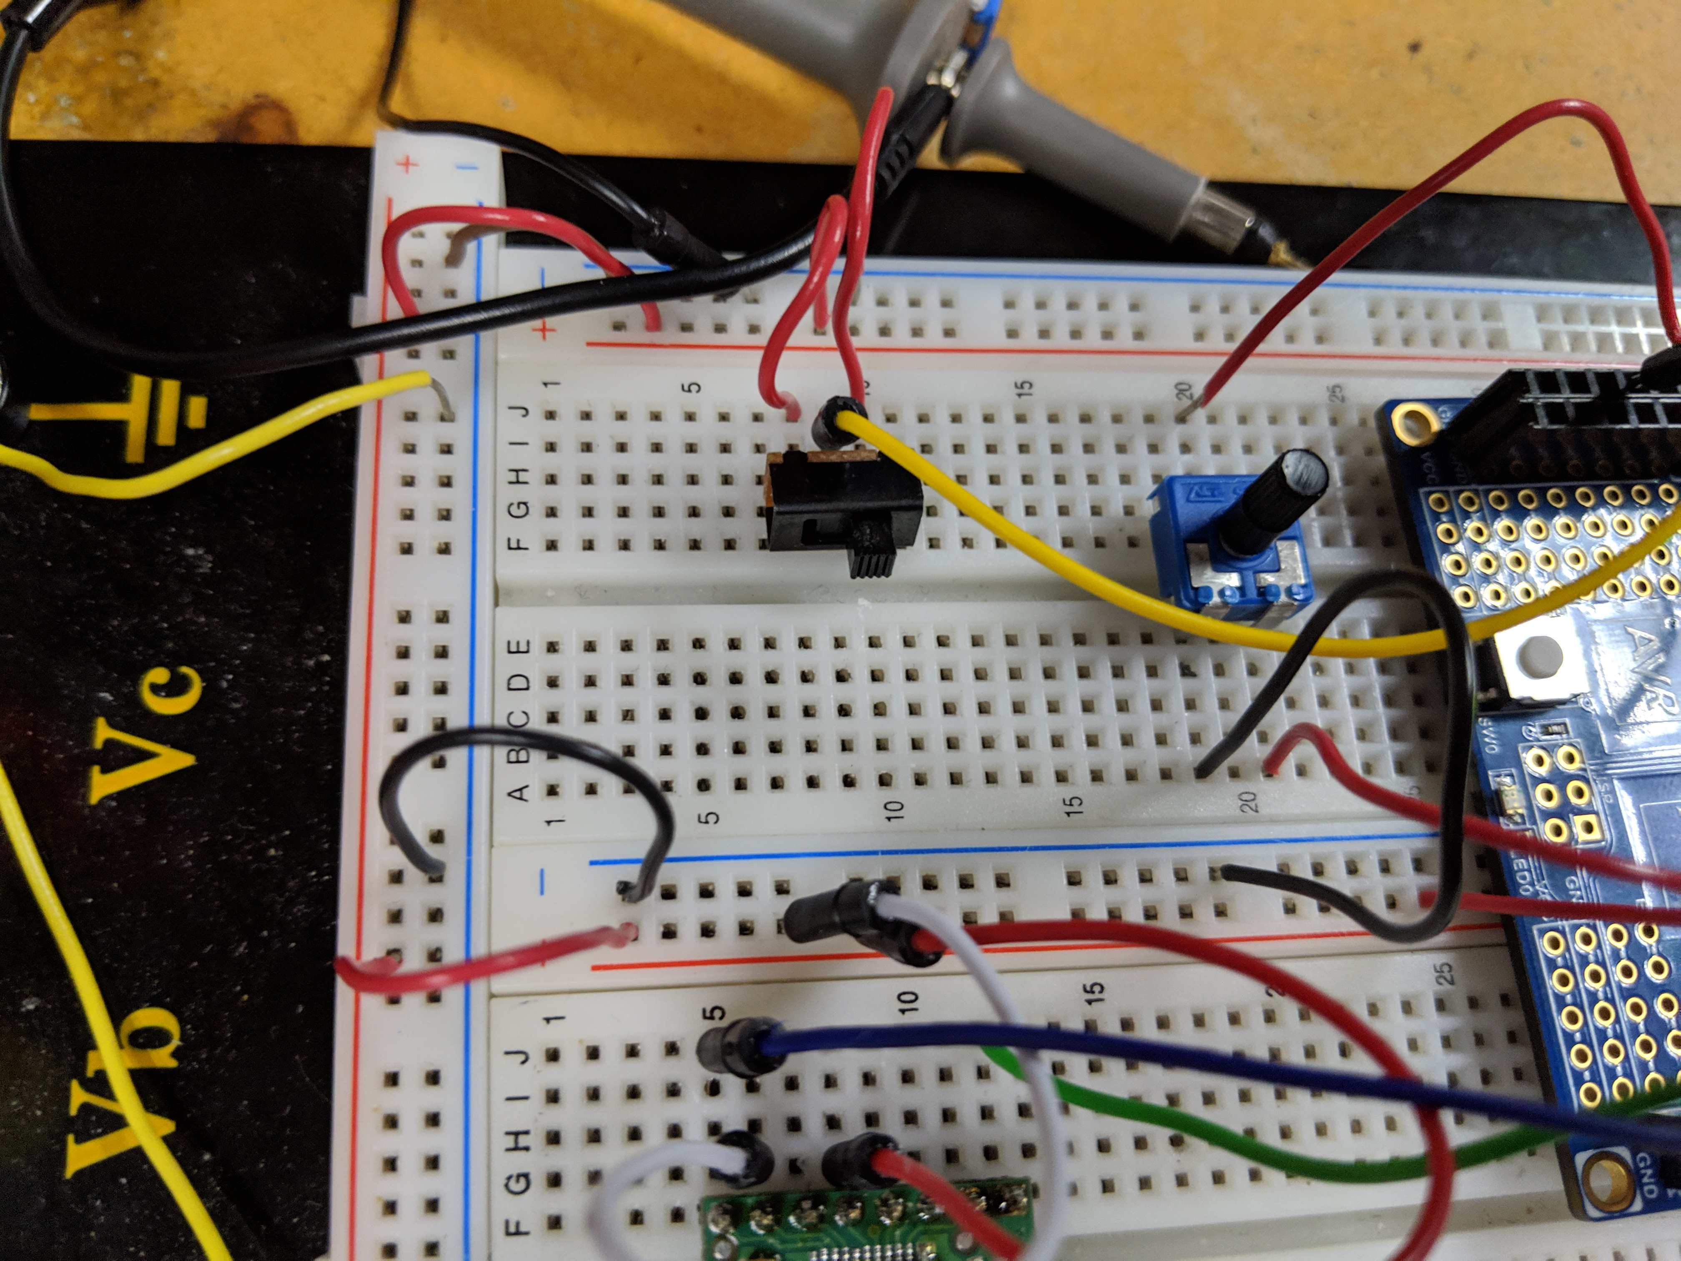

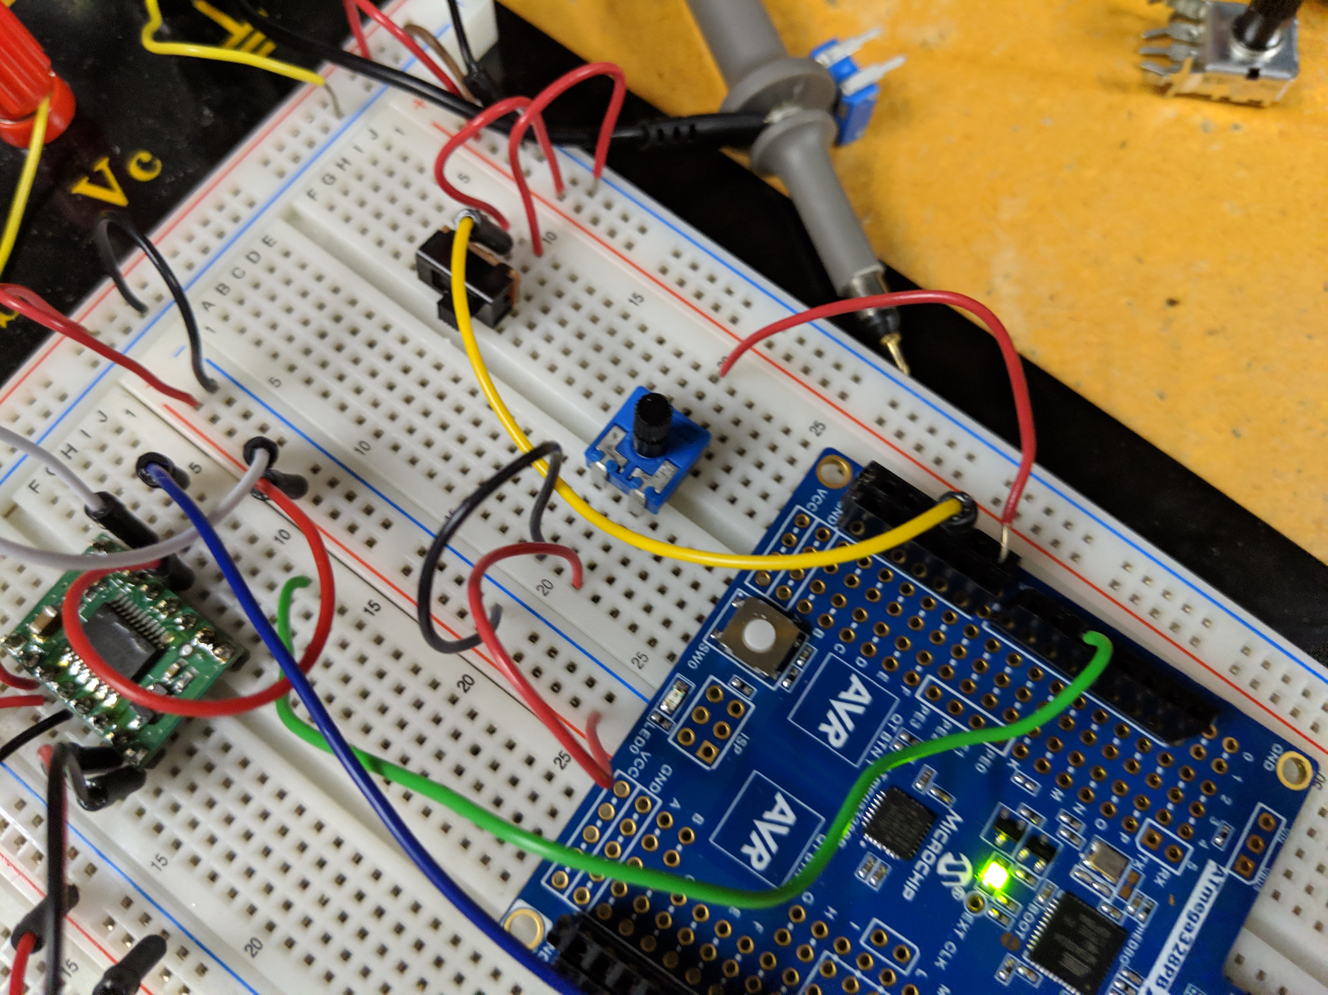

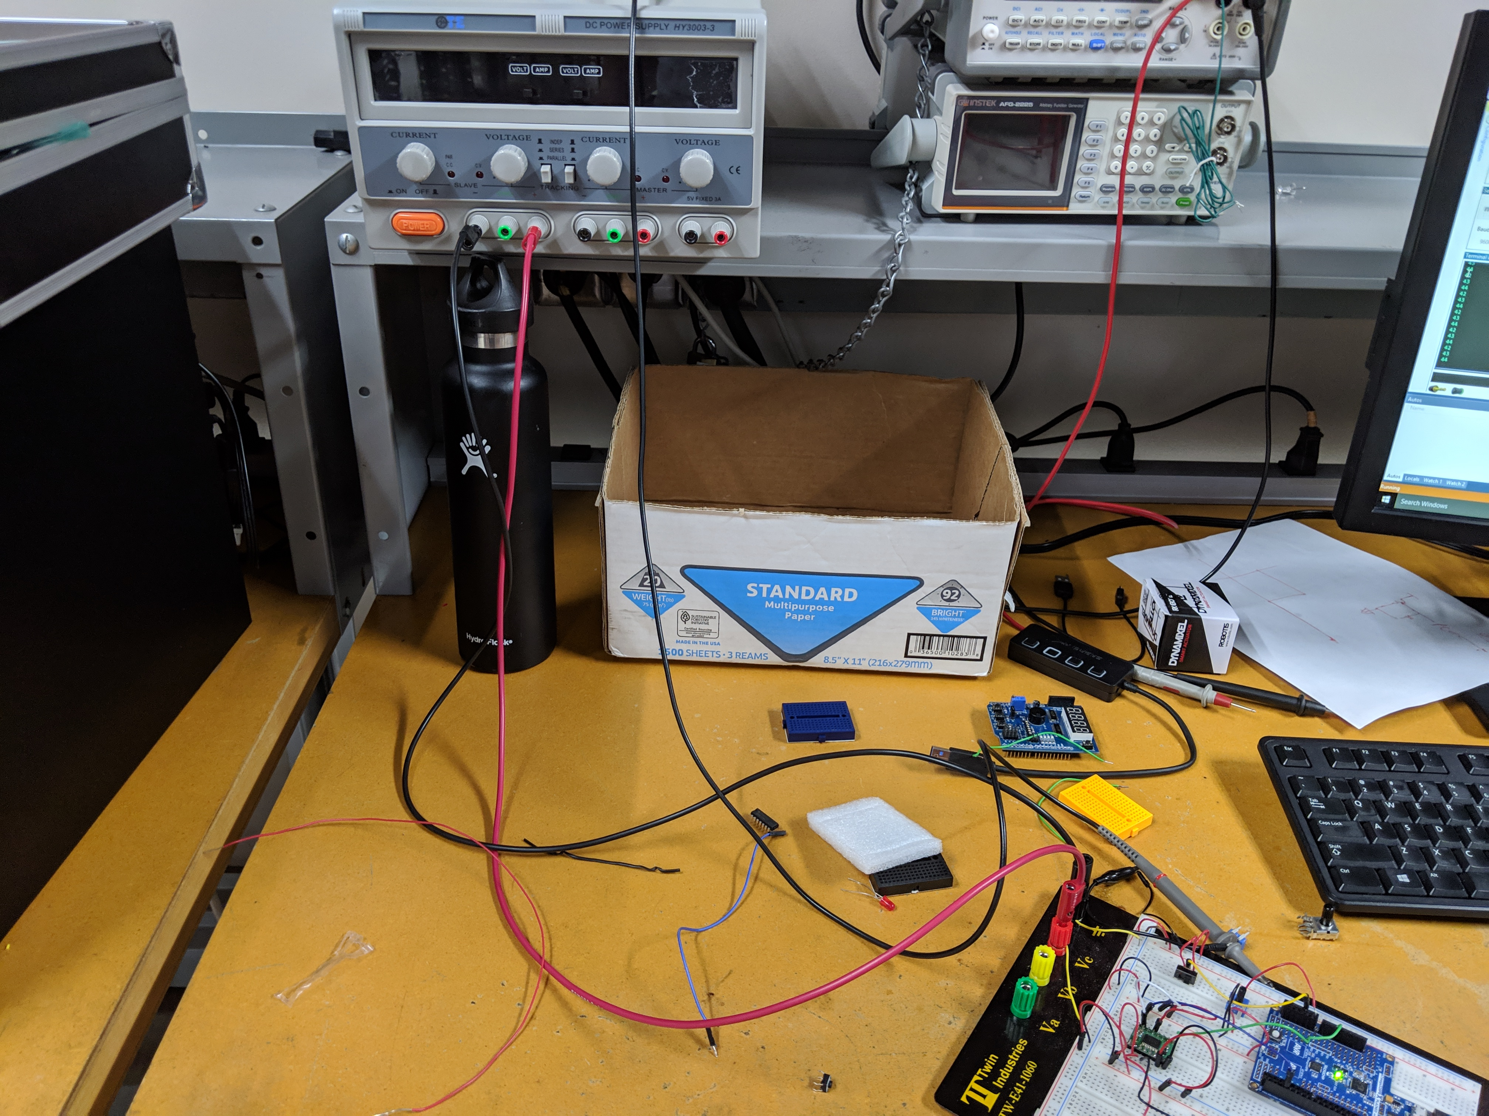

1. **VIDEO LINKS OF EACH DEMO**

<https://youtu.be/ihUMtjo27XE>

1. **GITHUB LINK OF THIS DA**

<https://github.com/claytonjhigbee/CODSWORTH_MAIN/tree/master/DA/DA4A>

**Student Academic Misconduct Policy**

<http://studentconduct.unlv.edu/misconduct/policy.html>

“This assignment submission is my own, original work”.

Clayton Higbee